*Name: Aryan Sharma*

*Enrollment no. – BT21GCS161*

*Assignment no. – 06*

*Q- WAP for Insertion sort*

***Code –***

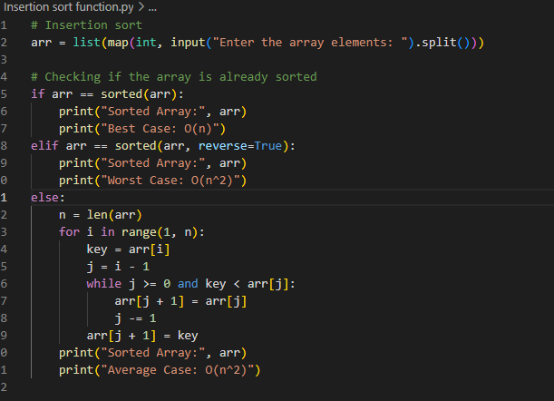

***Output*** –

***For Best Case***

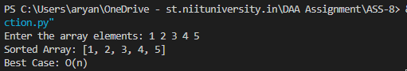

***For Worst Case –***

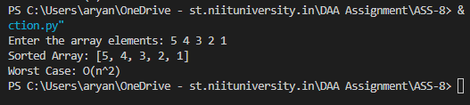

***For Average Case –***

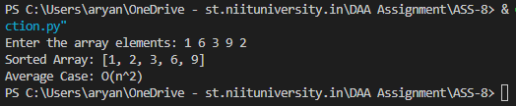

***Analysis –***

***Time Complexity – O(n2)***

***Space Complexity –*** *O(1)*

*Due to the already-sorted array no element swapping, the time complexity for the average and worst-case scenarios would be* ***O(n2),*** *but for the best-case scenario it would be O(n). In contrast, since the array is in reverse order in the worst-case scenario, every element must be compared and switched.*

*The worst-case scenario and the average case scenario have similar characteristics, resulting in the same level of time complexity. The space complexity in all three scenarios is O (1).*